Step 1 :Created a VisualForce page for custom button. Code for custom convert button VisualForce page is

LeadConversion.vfp

<apex:page standardController="Lead" extensions="LeadController" sidebar="false">

<apex:pageBlock tabStyle="Lead" id="LeadBlock" title="Custom Lead Conversion" >

<apex:pageBlockSection title="Lead Details">

<apex:outputField Style="text-align:left" value="{!lead.LastName}"/>

<apex:outputField Style="text-align:left" value="{!lead.OwnerId}"/>

<apex:outputField Style="text-align:left" value="{!lead.Company}"/>

<apex:outputField Style="text-align:left" value="{!lead.Id}"/>

<apex:outputField Style="text-align:left" value="{!lead.Status}" id="leadStatus"/>

</apex:pageBlockSection>

<apex:form >

<div align="center" draggable="false">

<apex:commandButton disabled="{! if(IsConverted , true, false)}" value="Start Conversion" action="{!convertLead}" />

</div>

</apex:form>

</apex:pageBlock>

</apex:page>

Step 2 :Goto Setup > Quick Find Box>Search for Button, Links and Actions in Leads>Click on Button, Links and Actions in Leads> Below page is opened >

Click on new Button or Link

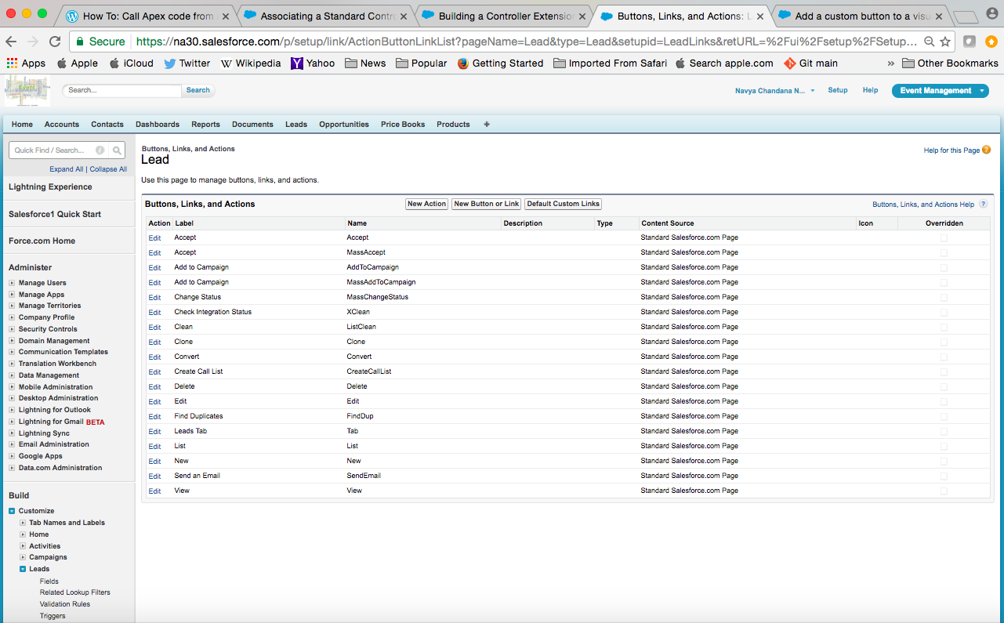

Step 3 : Below page appears

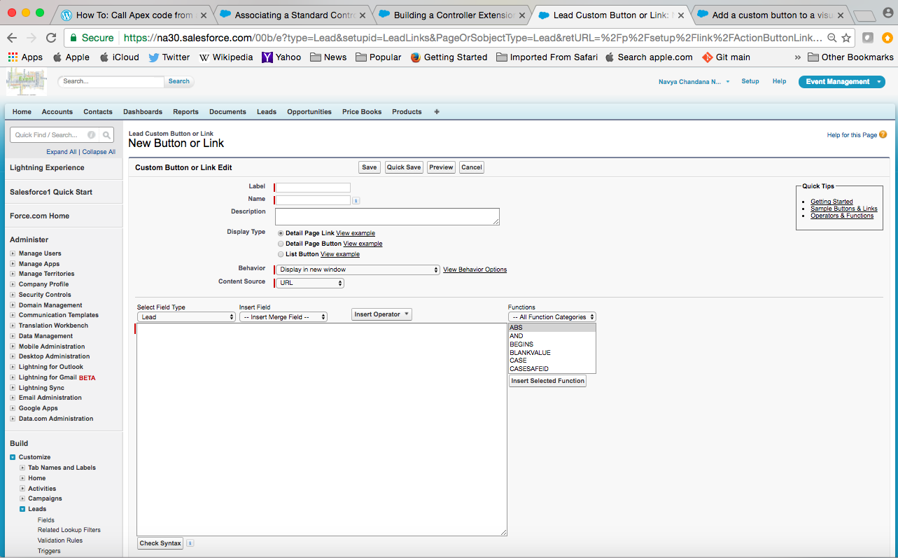

Step 4 : Give the Label name and Name will come automatically.

In Display Type Select Detail Page Button

Behaviour : Select Display in existing window with siderbar

Content Source : Visualforce Page

Content : Select the Visualforce Page(LeadConversion.vfp)

Click Save

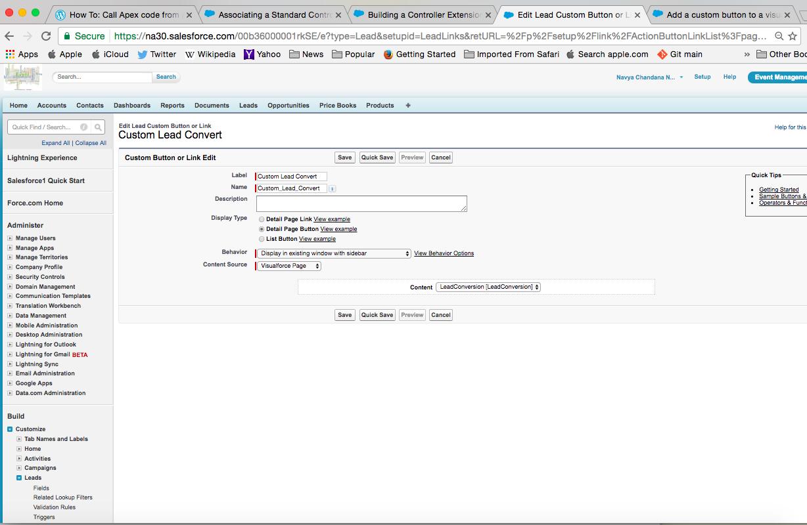

When we click save it shows a warning that the custom button can be visible when we add that button to pagelayout. Click ok.

Step 5 : Setup> Lead> Page Layouts

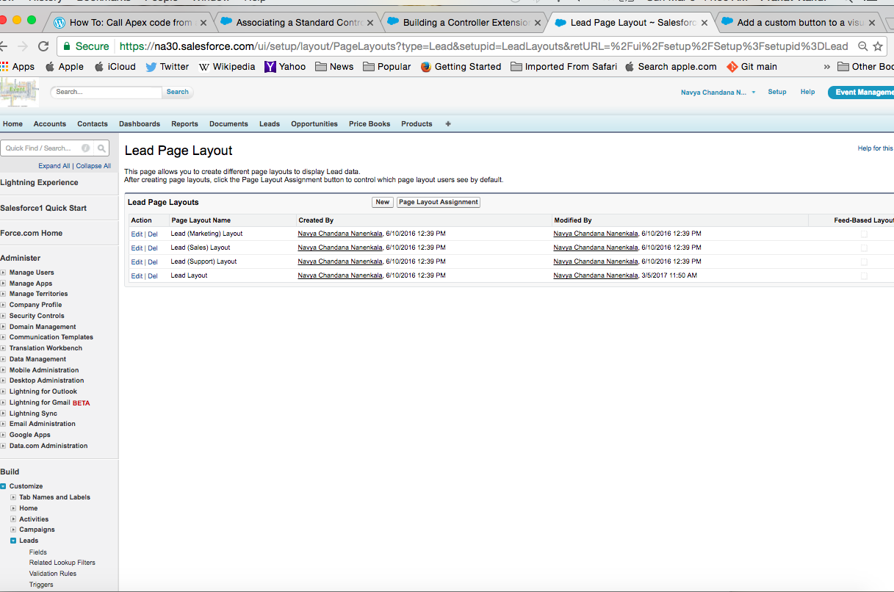

Step 6 : Select Lead Layout

Step 7 : Click on Button . Here we can see the custom button which we created.

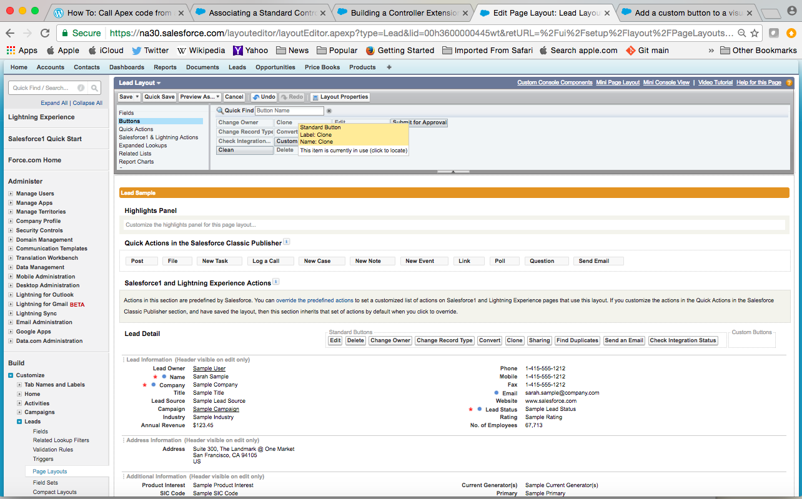

Step 8: Drag and Drop the Custom convert button to the Lead detail

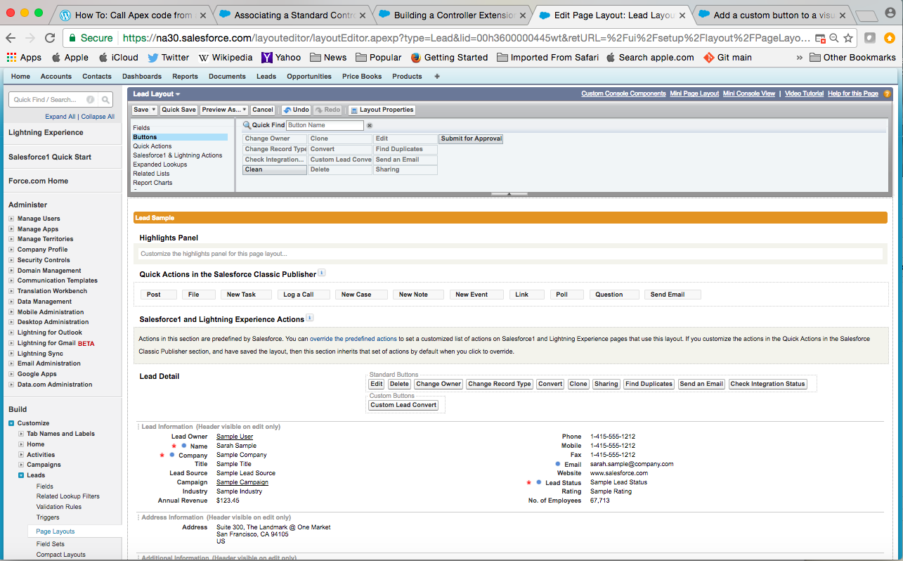

Click Save.

Step 9 : Setup>Click Lead Tab>Existing Lead

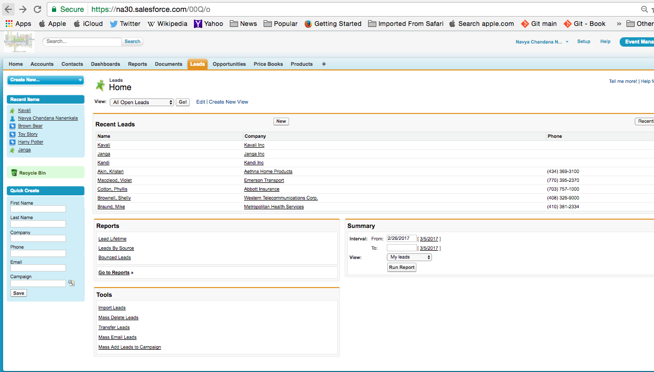

Step 10 : Click on Custom Lead Convert

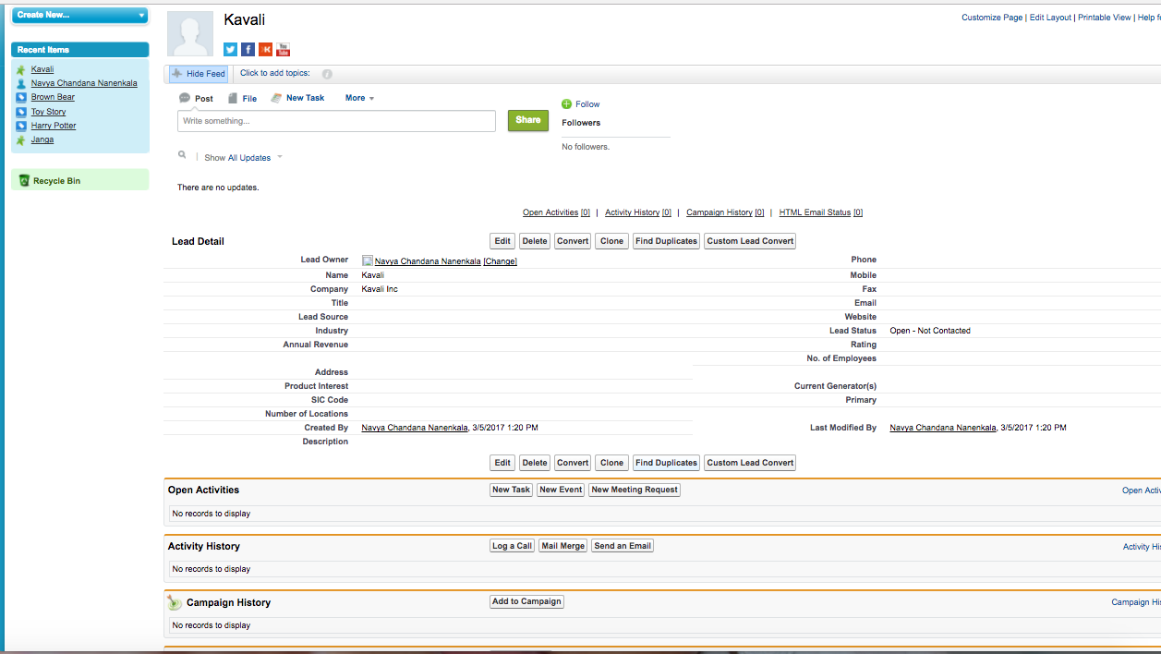

Step 11 : Click Start Conversion

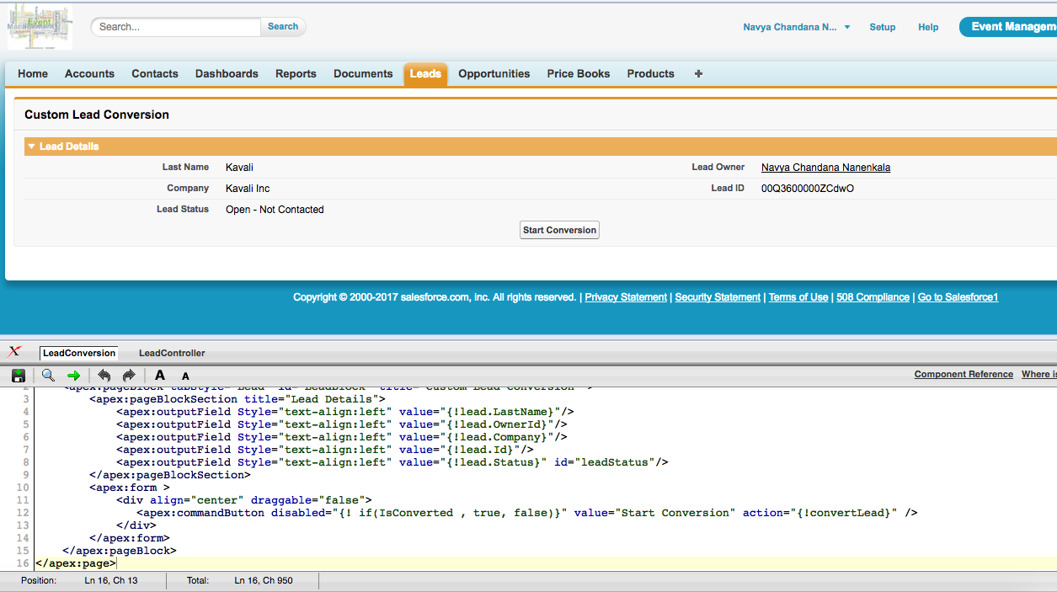

Step 12 : The output appears like this Conversion is done.

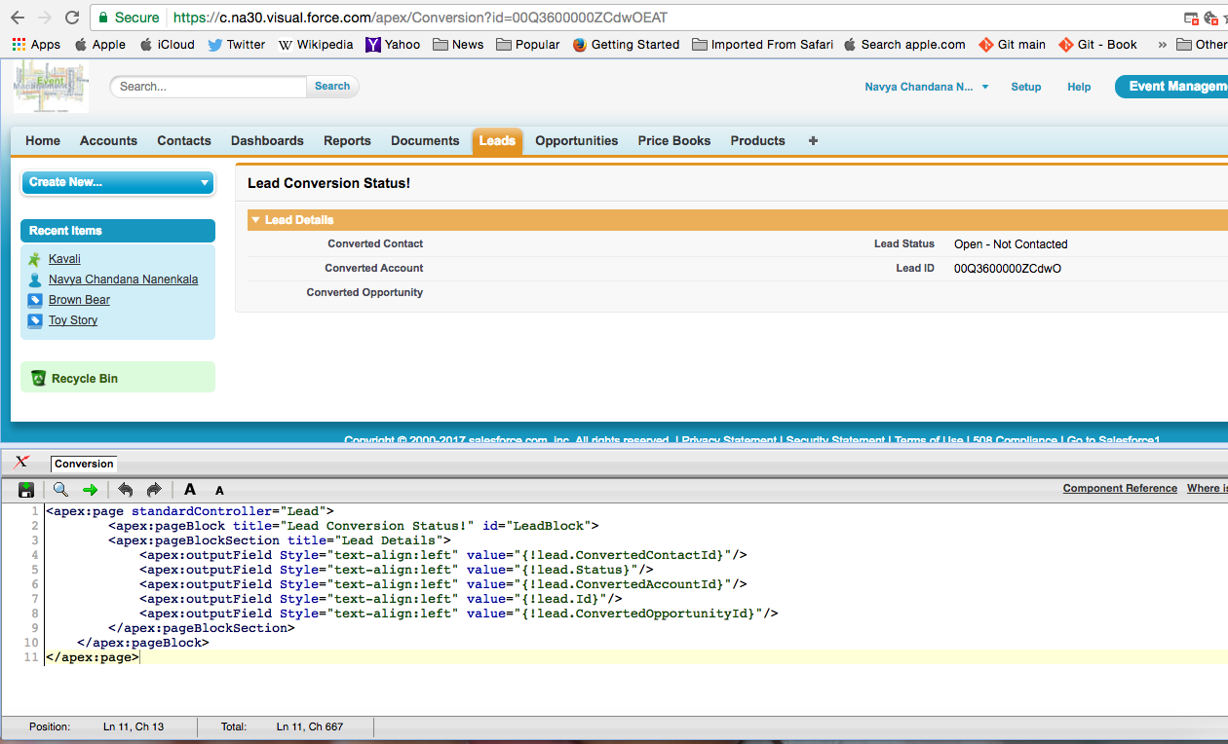

After conversion code(Conversion.vfp)

<apex:page standardController="Lead">

<apex:pageBlock title="Lead Conversion Status!" id="LeadBlock">

<apex:pageBlockSection title="Lead Details">

<apex:outputField Style="text-align:left" value="{!lead.ConvertedContactId}"/>

<apex:outputField Style="text-align:left" value="{!lead.Status}"/>

<apex:outputField Style="text-align:left" value="{!lead.ConvertedAccountId}"/>

<apex:outputField Style="text-align:left" value="{!lead.Id}"/>

<apex:outputField Style="text-align:left" value="{!lead.ConvertedOpportunityId}"/>

</apex:pageBlockSection>

</apex:pageBlock>

</apex:page>

Controller for Lead (LeadController.apxc)

public class LeadController {

public Lead lead = new Lead();

public Id Lid, accId, conId, oppId;

public Boolean isConverted = false;

public LeadController(ApexPages.StandardController stdController){

Lid = (Id)stdController.getRecord().id;

lead = (Lead)stdController.getRecord();

System.debug(Lid);

}

public Lead getLead(){

return lead;

}

public PageReference convertLead(){

//lead = [SELECT Id ,LastName,Company,Status, OwnerId FROM Lead WHERE Id =:Lid LIMIT 1];

lead[] l = [SELECT ID, LastName, Company, Status, OwnerId From lead WHERE Id =:Lid LIMIT 1];

Database.LeadConvert ldconvert = new Database.LeadConvert();

ldconvert.setLeadId(lead.id);

ldconvert.setOwnerId(lead.OwnerId);

ldconvert.ConvertedStatus = 'Closed - Converted';

ldconvert.setSendNotificationEmail(true);

try{

Database.LeadConvertResult result = Database.convertLead(ldconvert);

System.Debug('Conversion Result: ' + result.isSuccess());

if(result.isSuccess()){

isConverted = true;

}

}

catch(DmlException e){

System.debug(e.getCause());

}

PageReference returnPage = new PageReference('/apex/Conversion?id='+ Lid);

returnPage.setRedirect(true);

return returnPage;

}

public boolean getIsConverted() {

if(isConverted || lead.Status == 'Closed - Converted')

{

isConverted = true;

}

return isConverted;

}

}